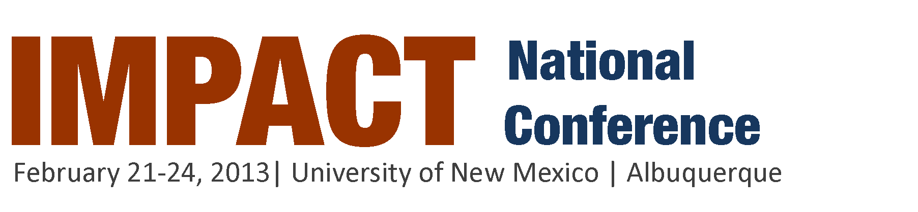
Call for Workshop Proposals
The IMPACT Conference brings together college students, nonprofit professionals, campus administrators, and year of service members to share best practices, experiences, stories, and resources in their work for social change. Quality workshops are pivotal to our program, and we are excited that you are interested in facilitating a workshop at this year's conference.

Workshop Categories
- Building and Enhancing Community Service Programs
- Administrators
- Alternative Break Programs.
- AmeriCorps/National Service/Year of Service programs
- Issue and Advocacy
- Leadership and Professional Skills/Career Development
- Life after College/Recent Graduate
- Service-Learning
- Spirituality/Faith and Service
Submission Instructions
You can submit through the online form http://www.impactconference.org/workshops/call-for-workshop-proposals/ or by completing the form starting on page two of this document. Please delete this first page before you submit. Also, rename the document starting with your last name and then brief portion of your workshop title, ie : “Obama – How to run for president.” Email to workshops@impactconference.org.
Please submit your proposal by the following date(s):
EARLY BIRD: Friday, November 2, 2012 at 11:59 pm Eastern Standard Time.
Proposals will be evaluated and you will be notified of its status by November 12, 2012.

FINAL SUBMISSION: Monday, December 10, 2012 at 11:59 pm Eastern Standard Time.
Proposals will be evaluated and you will be notified of its status by December 17, 2012.
Proposal Selection Criteria
When reviewing the workshop proposal submissions, the committee will complete our evaluation based on the following criteria:
- The content offers a significant contribution to the purpose of the conference and can clearly fit into a specific area.
- The workshop has a clear purpose and objectives.
- The workshop format is dynamic and engages the audience through participation and discussion.
- The workshop provides the audience with concrete ideas/models that can be applied on their campus and/or community.
For more information or to browse workshops from previous conferences, visit www.impactconference.org.
Workshop Proposal Submission Form
* Required
I have reviewed the above expectations. * Yes
Lead Facilitator's Last Name *
Lead Facilitator's First Name *
Lead Facilitator's Email *
Lead Facilitator's Phone Number *
Name of Organization or College *
Social Media Links *(optional)
Twitter/FB Page/LinkedIn/etc.
Have you previously facilitated this workshop? Yes No
If you answered yes to the previous question, who was your audience?
Bio of Lead Facilitator
Please provide a brief bio for the lead facilitator. * Bios should be limited to 100 words or less. This information will be published.

Names of Other Proposed Facilitators
If you do not have names yet, please insert placeholders (i.e. student presenter 1, nonprofit presenter 2, etc.)
Please provide a brief bio for each co-facilitator.
Bios should be limited to 100 words or less. This information will be published.
What is the title for your proposed workshop? *
Titles should be 35 words or less. This information will be published.
Please give a brief description of your proposed workshop. *
Workshop descriptions should be 250 words or less. This information will be published.
Please list the intended outcomes for the participants of your workshop. *
Please provide a brief outline of your workshop. *
Availability
Please select days that are you are available to facilitate your workshop. * Select all available options -- the Workshops Team will do our best to accommodate your request.
Friday, February 22, 2013 Saturday, February 23, 2013
Are you interested in facilitating your workshop twice during the conference? * Yes No
Best Practice Sharing:
Some workshops more readily take the form of the sharing of a best practice from a campus or organization, while others are more of a designed workshop not limited to sharing from one campus. In the event that we may seek to combine similar workshops, please indicate below if your workshop is primarily the sharing of a best practice:
Yes No
Scope of Impact
Additionally, this year we will be adding a designation of scope of impact of workshops. Therefore, please indicate below the range of your presentation:
- Local/Community
- National
- Global
Equipment/Materials Needs
Please select the materials that you would like for your workshop. * We will do our best to meet your needs, but will let you know about our ability to fill this request closer to the date of the conference.
- None
- LCD Projector
- Internet Connection
- White Board/Easel and Markers
- Other:

Workshop Category
Select an area that best fits your workshop. * Please select one. This information will be published.
- Community Service Programs: This area features workshops on components and strategies for building strong service programs, such as recruitment, retention, orientation, training, program structure, meaningful service, evaluation/outcomes, reflection, funding and organizational sustainability, and strategic partnerships.
- Service-Learning and Community-based Research: This area features workshops on ways to connect community engagement with your academic work, including working with community partners, teaching pedagogy, service-learning and community-based participatory research, building research questions, reflection, engaging departments, and working with faculty.
- Issues and Advocacy: This area features workshops on countering racism, classism, sexism and other forms of prejudice; environmental justice; addressing domestic poverty; international public health; economic justice; addressing climate change; education policy; hunger and homelessness among other topics. This area also features workshops on active forms of civic work such as online organizing tools/techniques, creative community-building, working with elected representatives, building coalitions, working with student government, creative public relations and communications on campus, and working across your campus.
- Leadership and Professional Skills/Career Development: This area features workshops that are focused on individual skills and benefits. This area can include “how-to” topics (i.e., how to write a press release, how to create a budget, funding your ideas, corporate social responsibility nonprofit/private partnerships and leveraging the private sector for public good etc.) as well as focusing on leadership development and management skills.
- Administrators Area: This area is designated for workshops targeted at administrators of campus programs. Workshops include topics such as sustainable funding for student-led organizations, applying civic engagement theories to programs, as well as how to improve service-learning efforts on any type of campus.
- Alternative Break Programs (sponsored and managed by BreakAway): This area features workshops that introduce AB to students while stressing the significance and benefits of becoming involved. This area also impresses upon students the local impact of these programs, as well as provides opportunities to become involved with alternative break programs.
- Life after College/Recent Graduate Area: This area features workshops that focus on graduate school programs, post-grad service programs, and service opportunities for recent grads, an example is: "How to create a service program at your workplace or in your community" This area also features workshops on leadership development, management skills, nonprofit career paths, and graduate education.
- AmeriCorps/National Service/Year of Service/Bonner Young Professional Programs: While content may be applicable to other areas, these workshops are designated for these members and program staff.
- Spirituality/Faith and Service: For many people spirituality and faith are a cornerstone of their commitment to service and justice. Explore how to deepen, honor, and leverage the spiritual and faith-based roots of service.
Availability for Webinar
This year the workshops team will be offering one complementary group webinar presentation training session for our presenters. Below are days and times that webinars will be offered. Please select one that is the most convenient for you*:
Available on Monday after 4 p.m. EST Available on Thursday after 8p.m. EST

